|  |
| --- |
| Monitoring Design |
| Major Project – CS39440 |
| Version 1.0 |
|  |

|  |
| --- |
| Robert Mouncer (rdm10@aber.ac.uk)  Software Engineering MEng - G601  Supervisor – Neal Snooke (nns@aber.ac.uk) |
|  |

Introduction

This document is written for the air quality mapping project, this project is for Robert Mouncer’s major project in Aberystwyth University. This document will contain the design for the second part of the major project, the major project is split into two parts, monitoring and visualization, this document will cover the visualisation side.

The visualisation application will be used to visual the data recorded by monitoring side of the project. This data is stored on the Aberystwyth University computer science MySQL server. The aim is to show the data in an interactive way for educational purposes. No hardware is involved in this process. This document will show the layout of the pages and how the data will be retrieved from the server.

# Software

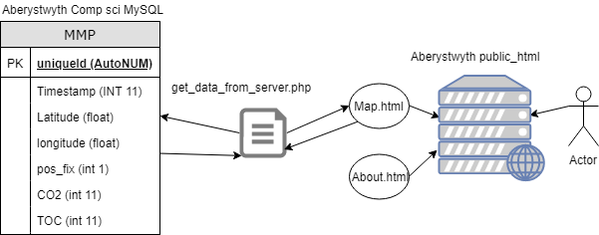

The user will have access to two web pages. The map webpage will contain the interactive map for the user to visualise the data. The about page will just contain information about what the page is for and how to install it. The “get_data_from_server.php” will be executed on the server side to keep separate the access to the database.

## Map.html

This page will contain the map for the user to interactive with and visualise the data. The map will be provided by openstreetmaps, there is no license to use the map and all it needs is recognition, it is free to use and open source. A plugin will be used to create the heat map overlay onto the map.

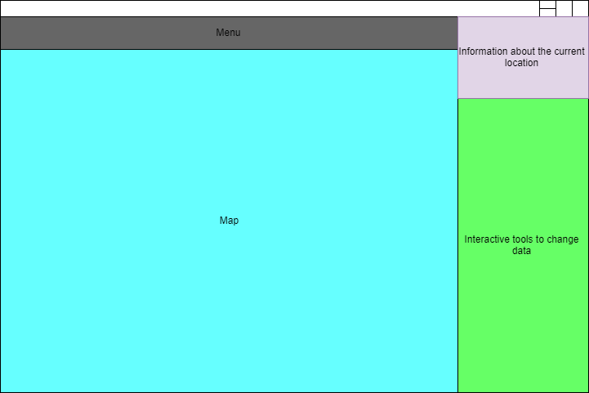

Most of the page will be for the map. On the top will be the navigation menu. The information about the current location section should display how the air quality could effect human health and the environment around it. The interactive tools are yet to be confirmed but should be used to modify the data.

## About.html

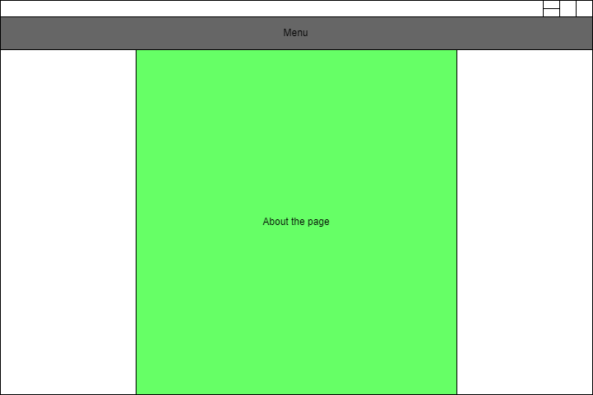

The about page will be very simple with information about the page displayed in the centre, with additional comments on how to use and install the page for personal use.